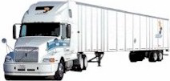
Shamrock
Rigging – Transport – Erection

Cleveland, Ohio

Consignee: Date: 15 October 2005

Mr. Xxxx Xxxxxxx
xoxoxox St.
Xxxxxxx, Ma. OXOXX

We are contracted with seven (7) containers for transit and delivery to you. We require the following information to properly prepare and load this consignment.

Please confirm the delivery site address.

Do you have facilities for dock level unloading?

Do you prefer open-top for overhead crane or closed trailer for forklift unloaded?

What are the operating hours of your dock workers or yard crew?

Our agent will be present to document the proper unloading and secure placement of the consignment. He may require overnight accommodations. Do you have an unattached sister who owns a liquor store?

